Objective
This document provides the procedure for gaining approval to cannibalize a part, the process followed to complete the cannibalising cycle including the repair strategy, stocking, the use of, and the pricing of cannibalized parts used in repair when cannibalizing is performed by Burrana or an external vendor.

This procedure also defines Burrana Inc.’s compliance approach to FAA Part 145 regulations for cannibalization, ensuring that all activities maintain serviceability, traceability, and airworthiness of cannibalized parts. This procedure addresses regulatory compliance requirements without instructing on operational execution, which is covered in related SOPs.

Scope
This procedure applies to all repair station operations where cannibalization may be deemed necessary due to inventory constraints, operational needs, or specific regulatory requirements.

Acronyms
Term | Meaning
ATA | Air Transport Association
BER | Beyond Economical Repair
CFR | Code of Federal Regulations
EASA | European Aviation Safety Agency
FAA | Federal Aviation Administration
LRU | Line Replaceable Unit
MSN | Manufacturing Serial Number
OEM | Original Equipment Manufacturer
CMM | Component Maintenance Manual
URA | Unit Routable Available
MRB | Material Review Board
SOP | Standard Operating Procedures
NCR | Non-Conformance Required

Definitions

Term | Meaning
Material =CAN | Standard parts non-serviceable identified as candidate to be cannibalized and finally certified as serviceable part.
Material =REC  (Cannibalized part) | Used parts recovered which are not new and which were tested, inspected, and certified as serviceable by an approved Maintenance Organization (Service Center).
BER | When the cost to refurbish a part exceeds 60% of the cost of new, it will be determined to be too costly to repair or Beyond Economical Repair.
Traceability data | Documents with enough information & data to establish the traceability to ensure that equipment or material has not been involved in an accident or it is not a counterfeit part.
Golden Unit | A unit required to be part of test setup to tun an acceptance test.

General
Cannibalization activities are covered within the Burrana Repair Station Manual and Quality Control Manual to meet 14 CFR Part 145 requirements. These manuals outline the repair station’s commitment to regulatory adherence and compliance in part removal and installation. Any cannibalization actions will follow documented protocols acceptable to the FAA
Suffixes of “=CAN” or “=REC” will be used to identify the status of material in the MRP system & paperwork only, the parts never will be identified physically with these suffixes.
Material =CAN must be identified using Cannibalization Traceability Form F-859-09 for a cannibalized part, controlled, and maintained in quarantine area identifying its condition using a rejection tag and have all traceability data attached to the part.
Acceptable traceability must be available. Acceptable traceability may be tear down repair of maintenance activity of previous visits and/or Part or LRU received has certified statement as to identity and condition. CFR Part 43.13, Order 8130.21, AC 20-62, and EASA AMC No. 2 145.A.50 section 2.8 provide guidance on the requirements for accepting used parts:
- Part number, serial number, and maintenance history of the cannibalized part.
- Source of the part and all applicable records.
- Maintenance and inventory logs updated to reflect cannibalization activities for regulatory traceability.
Personnel conducting cannibalization activities must possess the necessary qualifications and training per 14 CFR § 145.163. Burrana’s training program includes regulatory requirements and best practices related to the airworthiness and traceability of Refurbish/cannibalized parts. Records of personnel training are maintained within the repair station’s documentation system.
Burrana conducts regular audits of cannibalization activities to ensure compliance with FAA requirements. Included in the MRC Audit plan.
Raw or consumable materials cannot be identified as material =CAN. Only MRB approved standard parts can be identified as =CAN
Life sensitive electrical parts (i.e., light bulbs, electrolytic capacitors in power filter applications, etc.) must be inspected before use and should not be used if they are believed to be incapable of remaining serviceable for the duration of the repair/overhaul warranty period (12 months).
Cannibalized parts are intended to be used to minimize the service support costs associated with the obtention of obsolete materials for repairs, used as part of a Recycling Program, or to meet service needs.
Candidate parts to be recovered shall always be identified with a part number suffix of "=CAN" and maintain the traceability data on its historical record of the same part and their respective source components.
Cannibalized Parts shall always be serialized identified in Epicor system as with part number suffix of "=REC", and the appropriate Acceptance Tag(s). Cannibalized stock shall always be stored in a separate warehouse location, in a separate storage bin to prevent commingling with "new" versions of the cannibalized part. The =REC suffix indicates that the part has been cannibalized and has been tested and inspected to a serviceable condition.
When a part is cannibalized, and has an acceptance tag, the part shall be deemed equivalent to the same base number for traceability and eligibility according to engineering and repair specifications.
Cannibalized parts will not be sold directly to external customers, with a few rare exceptions. These exceptions may include issues like obsolescence. All exceptions must be approved in advance by the Material Board Review leadership.
Cannibalized parts cannot be used if a customer has specifically requested new parts. If new parts are unavailable due to obsolescence or other supply related issue, the Service Center Customer Service team shall contact the customer to gain approval for the use of the Cannibalized part.
For any repair for a subassembly or top level LRU that is to be returned to stock as “NEW,” Cannibalized parts are prohibited. Any used part in a “NEW” unit makes the unit itself “USED” and therefore cannot be restocked as “NEW.”
Any revisions to this procedure will undergo Quality Assurance review and FAA approval as necessary. This procedure becomes effective upon FAA acceptance and will be included in Burrana's approved Repair Station Manual and Quality Control Manual

Process used to establish a cannibalized part

Determine Cannibalization Requirement

Confirm the part cannot be sourced through standard procurement or inventory channels.

Initiate the Material Review Board (MRB) process to identify obsolescence or supply issues.

Obtain input from Purchasing and Engineering to assess the feasibility and necessity of cannibalization.

Obtain MRB Approval

Complete the MRB process, including discussions with Purchasing and Engineering, to verify that cannibalization is the most effective solution.

Document MRB approval (NCR) for cannibalization, including part identification details and justification for removal.

Fill the Cannibalization Traceability form F-852-06

Section A. Part Identification.

Select a suitable subassembly in Burrana’s inventory that contains the required part, ensuring it qualifies for cannibalization.

Review maintenance and inspection records of the source subassembly to confirm airworthiness documentation.

Enter part number, description and serial number of the part, if the component is not serialized, request a serial number for the part (as “=CAN”).

Update inventory records to reflect the candidate (“=CAN”) for cannibalization candidate.

If the Original supplier Name and CofC is not available indicate the information as N/A o similar.

Section B. Source sub-assembly information

Ghater sub-assembly information: Part Number, Serial number (if available).

Ghater TOP unit, from where the sub-assembly was removed. Part Number and serial number.

Check the maintenance History at TOP Unit information. Attach information.

Ensure there are no airworthiness directives, service bulletins, or regulatory restrictions that impact the part’s eligibility to the corresponding TOP Unit.

If the source subassembly is NOT good working conditions, remove the part to be cannibalized, follow the removal instructions as detailed in the Component Maintenance Manual (CMM) or Standard Practice Manual (SPM). Use only approved tools, adhering to required handling and safety protocols to avoid part damage if the part is in good working condition do not remove the part at this point.

If removed, indicate when the part has been removed and the technician that removed the part stamp or initials, else indicate “N/A”

Attach source subassembly and TOP Unit traceability information.

Section C. Functional/test Inspection

Ensure that the part to be cannibalized is listed in the corresponding capability list. If not open a request to be added in our capability list.

Open a cannibalization Job order (=REC)

Perform a functional Test of the part on the source subassembly or source TOP unit as applicable, if the source subassembly is in good working condition test the part installed in the source subassembly, if not:

For electronic / electric parts run a test using a golden unit or the same source sub-assembly / TOP unit.

For mechanical parts perform a fit test using a golden unit or the same source sub-assembly / TOP unit.

Perform a Part Inspection. Conduct a detailed visual inspection for any signs of wear, damage, or contamination

If not previously removed, follow the removal instructions as detailed in the Component Maintenance Manual (CMM) or Standard Practice Manual (SPM). Use only approved tools, adhering to required handling and safety protocols to avoid part damage.

Attach the Cannibalization Traceability form F-852-09 and Identify the Cannibalized Part.

Update the inventory management system or digital logs to show the part’s new status and location as “=REC”.

Submit for Quality Assurance Review
            - Attach Records in Compliance with Regulatory Requirements to the cannibalization Job order (=REC)
            - All Maintenance History logs
            - MRB approval (NCR)
            - Source subassembly and TOP Unit traceability records
            - Return to Service certificate
            - Form F-852-09

Retain all documentation as per regulatory timelines, ensuring records are readily accessible for FAA inspections.

Process flow to recover parts as cannibalized parts
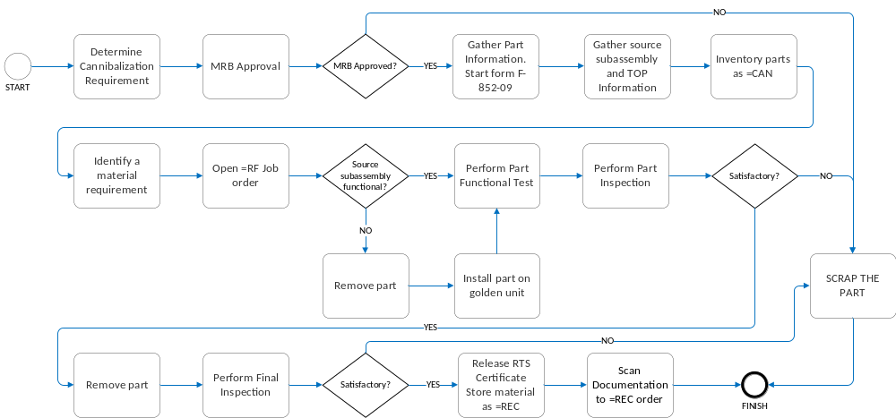

Governing Documents
- AS9100
- EASA Part 145
- FAA CFR Part 145
- FAA CFR Part 43.13
- FAA Order 8130.21
- FAA AC 20-62

Forms and Documented Information
- Cannibalization Traceability Form F-859-09

